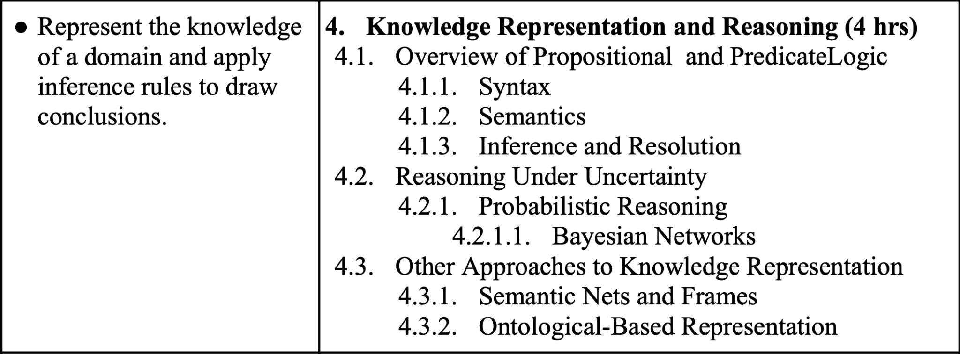

1. What is the use of logical connectives? List and describe formal logical connectives with truth tables and examples in compound statements.
2. Why do we need predicate logic? Discuss the rule of inferences of both propositional logic and predicate logic.
3. What do you mean by tautology, contradiction and contingency? Mention the inverse, converse and contrapositive of an implication. Prove that implication and its contra-positive are logically equivalent.
4. Explain the concept of probabilistic reasoning and how it is used to reason under uncertainty.
5. What is the Bayesian Network? Explain how Bayesian Network represents and inference the uncertain knowledge with an appropriate example.